List of courses

Academic year: | 2022-2023
Name of the Organization: | Oracle Academy

S. No. | Date(s) | Name of the Course | Number of students Enrolled | Number of Students Certified
1 | Apr 2023-June 2023 | Database Programming with SQL | 210 | 150
2 | Apr 2023-June 2023 | Database Design | 210 | 150
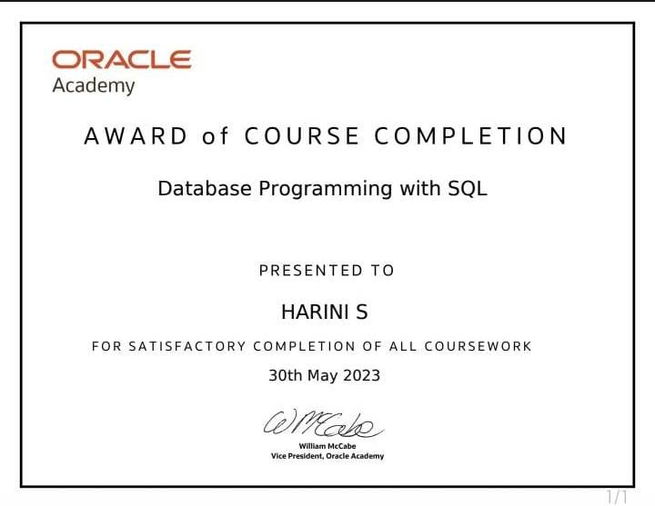

Academic year: | 2020-2021
Name of the Organization: | Oracle Academy

S. No. | Date(s) | Name of the Course | Number of students Enrolled | Number of Students Certified
1 | Apr 2021-June 2021 | Database Programming with SQL | 127 | 90
2 | Apr 2021-June 2021 | Database Design | 127 | 90
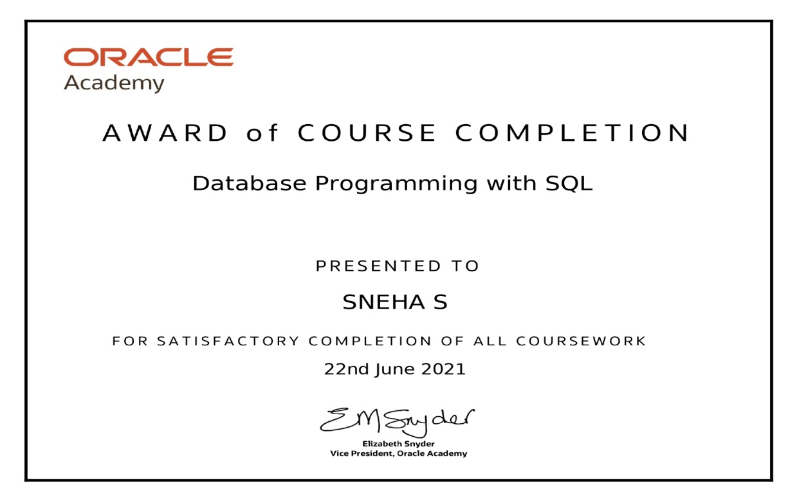

Academic year: | 2018-2019
Name of the Organization: | Oracle Academy

S. No. | Date(s) | Name of the Course | Number of students Enrolled | Number of Students Certified
1 | Aug 2018-Sep 2018 | Database Programming with SQL | 75 | 64
2 | Aug 2018-Sep 2018 | Database Design | 75 | 64
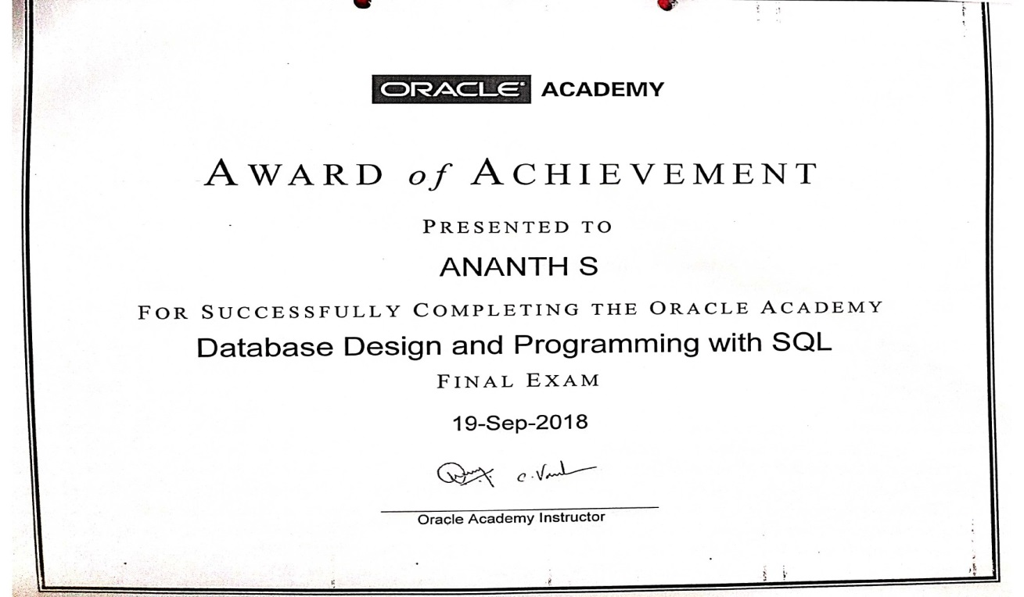

Academic year: | 2017-2018
Name of the Organization: | Oracle Academy

S. No. | Date(s) | Name of the Course | Number of students Enrolled | Number of Students Certified
1 | Aug 2017-Sep 2017 | Database Programming with SQL | 69 | 42
2 | Aug 2017-Sep 2017 | Database Design | 69 | 42
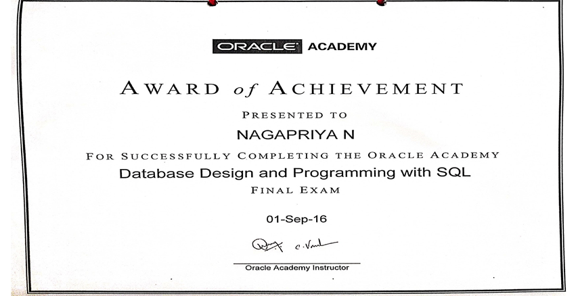

Academic year: | 2016-2017
Name of the Organization: | Oracle Academy

S. No. | Date(s) | Name of the Course | Number of students Enrolled | Number of Students Certified
1 | July 2016-Sep 2016 | Database Programming with SQL | 54 | 25
2 | July 2016-Sep 2016 | Database Design | 54 | 25

